
Press Release

6th International Pharos Contemporary Music Festival
4 – 8 October 2014
The Shoe Factory, Nicosia

The INTERNATIONAL PHAROS CONTEMPORARY MUSIC FESTIVAL has established itself as one of the most innovative and cutting-edge annual music events in Eastern Mediterranean. Under the artistic direction of the renowned Cypriot composer, Evis Sammoutis, the Festival is dedicated to the promotion of new music: The well-established masterpieces of the contemporary music literature of the 20th century as well as new works by the younger generation of composers, some of whom are commissioned by the Foundation to write new pieces especially for this occasion.

Organised between 4 and 8 October 2014 at The Shoe Factory in Nicosia, the 6th International Pharos Contemporary Music Festival focuses on the connection of new music and other forms of art, as well as alternative forms of contemporary music such as “free jazz” and electronics. The Festival will open on 4 October with an innovative concert-concept by the Ergon Ensemble during which films of the ‘silent era’ will be screened simultaneously with the live performance of new works, attaining therefore a new dimension, character and denotation. Over the span of five days, the Festival will feature a number of exciting events such as lectures, documentary screenings, educational activities, a recital with pianist Hayk Melikyan who returns to Cyprus to join forces with the fascinating violinist Hugo Ticciati, and it will conclude on 8 October with Soundspaces – “A concert of live electronics, improvisation and free jazz” by Johannes Schwarz (bassoon) and Sascha Armbruster (saxophone). The concert will take place at the roof-garden of The Shoe Factory which will be transformed for the first time as an exclusive open-air concert platform, where the audience will be able to enjoy an extraordinary, unconventional, musical experience in a leisurely setting with a glass of wine.

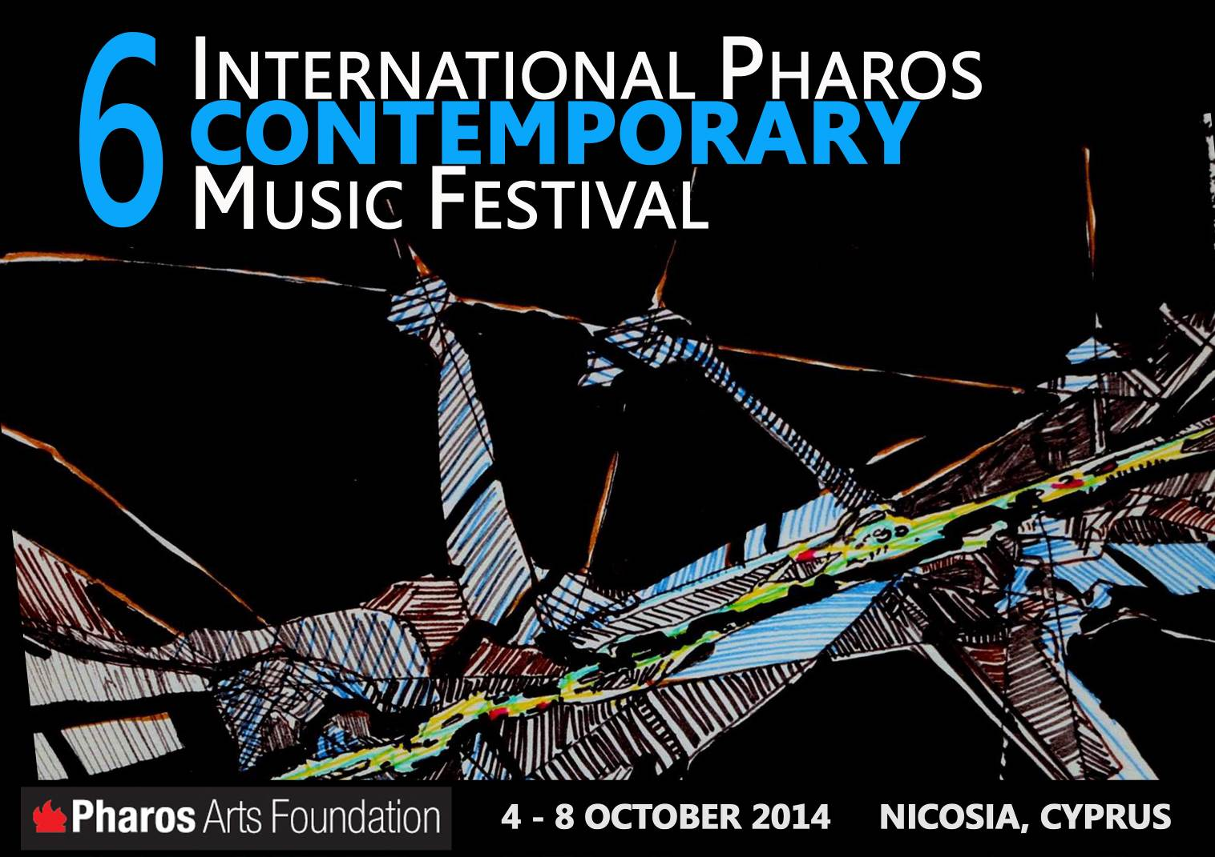
EVENT SCHEDULE:
DATE | TIME | EVENT
Sat 4 Oct | 11.00am | Educational Workshop For young composers and students of Media ERGON ENSEMBLE & ALEXANDROS MOUZAS
Sat 4 Oct | 8:30pm | Concert “Silent Films & Music” ERGON ENSEMBLE, ANDREAS TSELIKAS / CONDUCTOR
Sun 5 Oct | 3:00pm | Master-Class For young pianists and violinists HAYK MELIKIYAN / PIANO & HUGO TICCIATI / VIOLIN
Sun 5 Oct | 7:30pm | Lecture “Film music: from the silent era to the coming of sound”  ALEXANDROS MOUZAS / ARTISTIC DIRECTOR OF THE ERGON ENSEMBLE
Sun 5 Oct | 9:30pm | Screening Ost-original Soundtrack: "A documentary film about music in the motion pictures" DIR: FANIS LOGOTHETIS
Mon 6 Oct | 11:00am | Educational concert For secondary education students HAYK MELIKIYAN / PIANO & HUGO TICCIATI / VIOLIN
Mon 6 Oct | 8:30pm | Concert A violin and piano recital with works by Messiaen, Lutoslavski, Pӓrt, Takemitsu, Evis Sammoutis, Vito Zuraj, Esaias Järnegard & Albert Schnelzer HAYK MELIKIYAN / PIANO & HUGO TICCIATI / VIOLIN
Tue 7 Oct | 7:30pm | Screening of two short films: Re-Veil-Le and War & Peace: The Film  DIR: DOMINIC DE VERE  Talk “Living One’s Practice: Performing One’s work”  JOANNA JONES / VISUAL ARTIST
Tue 7 Oct | 9:30pm | Screening Steve Reich: City Life "A documentary" DIR: MANFRED WAFFENDER
Wed 8 Oct | 8:30pm | Concert “An open-air concert of live electronics, improvisation & free jazz” SOUNDSCAPES (JOHANNES SCHWARZ / BASSOON, SASCHA ARMBRUSTER /SAXOPHONE)
***All events will take place at The Shoe Factory main hall, with the exception of the last concert, on 8 October, which will take place at The Shoe Factory roof-garden.

INFORMATION & TICKETS:
Information: Pharos Arts Foundation Tel. +35722663871 / www.pharosartsfoundation.org
Tickets: Free Entrance to all the events with the exception of Concerts on 4, 6 & 8 October: €10
Box Office: Directly from the Foundation’s website www.pharosartsfoundation.org or Tel. 9666-9003 (Monday - Friday 10:00am-3:00pm)

CONCERT
“silent films & music”
eRGON ENSEMBLE

Saturday 4 October 2014
The Shoe Factory, Nicosia / 8:30pm
Entrance: €10

The 6th International Pharos Contemporary Music Festival will open on Saturday 4 October 2014, at The Shoe Factory, 8:30pm, with an innovative concert-concept by the Ergon Ensemble during which films of the ‘silent era’ will be screened simultaneously with the live performance of new works, attaining therefore a new dimension, character and denotation. The concert will feature cinematic masterpieces such as Un Chien Andalou – Luis Buñuel’s first film, written in collaboration with the surreal artist Salvador Dali, Joris Ivens’ Regen – a cinematic poem on the transformation of Amsterdam by rain, and Anemic Cinema – a Dadaist / Surrealist, experimental film by Marcel Duchamp, which depicts whirling animated drawings alternated with puns and whimsical rhymes in French. It will also feature Ralph Steiner’s short film Mechanical Principles – an abstract, mesmerizing look at the world of gears, pistons, and other forms of mechanical movement, which will be set to music by the two winners of the “Call for Works”.

According to Alexandros Mouzas, artistic director of the Ergon Ensemble, setting music to silent films is an enchanting process for composers and audience alike: For the composers because they discover a new ground – beyond “Absolute Music” – that is conducive for experimentation, expression and interaction, and for the viewers because they are given the opportunity to experience a new way of enjoying these classic films. Particularly in films which do not involve a conventional storyline, a linear narrative or actors who can express themselves through speech, the perspective of the co-creator composer is suggestive of new ways of interpretation. The concert presents cinematic milestones of the silent era – films which had influenced the industry’s later course. Stylistically, these films shift between the vague boundaries of Abstract Art, Dadaism and Surrealism, while at the same time, through a cinematic, photographic, poetic and musical dialogue, the viewers uncover the interesting partnerships of leading masters: Ivens with Eisler in Regen, Dali with Buñuel in Un Chien Andalou.

Un Chien Andalou, the short silent film by Luis Buñuel and Salvador Dali, is an illustrative example of the Surrealist cinematic expression. Inspired by the dreams of its creators, the film features a series of phenomenally loose scenes, which, based on Freudian theories, have often been interpreted as allegories. The script was completed in approximately ten days while the shooting of the film was finalised in about two weeks. The first public screening of Un Chien took place in Paris’ Ursulines and it was attended by a number of illustrious artists. According to Buñuel, his only condition as with regards to his collaboration with Dali was that the script would not contain any image or idea that could call for logical interpretation. Likewise, he emphasized the fact that “Nothing, in the film, symbolizes anything. The only method of investigating the symbols would be, perhaps, psychoanalysis. Beyond any symbolism, we were looking for a way to balance the rational with the irrational so that we could better comprehend the unspeakable and unite the dream with reality, the consciousness with the unconsciousness.”

Regen (Rain) belongs to the filmic tradition of City Symphony, such as Berlin: Symphony of a City and Man with a Movie Camera. This exceptionally striking and poetic film, which had internationally established Ivens as one of the most important filmmakers of the 20th century, describes the way in which Amsterdam is transformed on a rainy day: From the sunny streets to the worsening weather conditions, the first raindrops falling on the water channels, the drenched by the rain windows, sunshades, trams and streets, until the sky gradually clears and the sun comes out again. The film, which could be regarded as a documentary, does not concentrate on specific characters but on the city as a whole.

Visual artist Marcel Duchamp collaborated with Man Ray on the experimental film Anemic Cinema. The film consists of abstract spiral-rotating images which give the illusion of a three-dimensional motion. They are combined with nine rhymes-puns, attached to black cardboard discs, which are spinning with the aid of a gramophone. This Dadaist / Surrealist film aimed to minimize its content to just literary and visual footage (The word Anemic is an anagram of the word Cinema).

Ralph Steiner was an American photographer, pioneer documentarian and a key figure among avant-garde filmmakers in the 1930s. His still photographs are notable for their odd angles, abstraction and sometimes bizarre subject matter, while his experimental films are considered central to the literature of early American avant-garde cinema. Shot in 1930, his film Mechanical Principles, is an abstract, mesmerizing look at the world of gears, pistons, and other forms of mechanical movement. The film has often been set to music – and with the right soundtrack the end result is remarkably balletic, transcendental and mystifying.

Programme:

Film: Un Chien Andalou (1929)
Director: Luis Buñuel
Writers: Salvador Dali & Luis Buñuel
Music: Alexandros Mouzas (2013)

Film: Regen (1931)
Directors: Joris Ivens, Mannus Franken
Writers: Joris Ivens, Mannus Franken
Music: Hanns Eisler, Fourteen Ways of describing the Rain, Op.70 (1941)

Film: Anémic Cinéma (1926)
Director: Marcel Duchamp
Music: Yannis Kyriakides (commission by ERGON- 2013)

Film: Mechanical Principles (1930)
Director: Ralph Steiner
Music: Winners of the Festival’s “Call for Works”

Transit for Piano & Video (2009) by Michel Van der Aa

ERGON ENSEMBLE
Andreas Tselikas / conductor
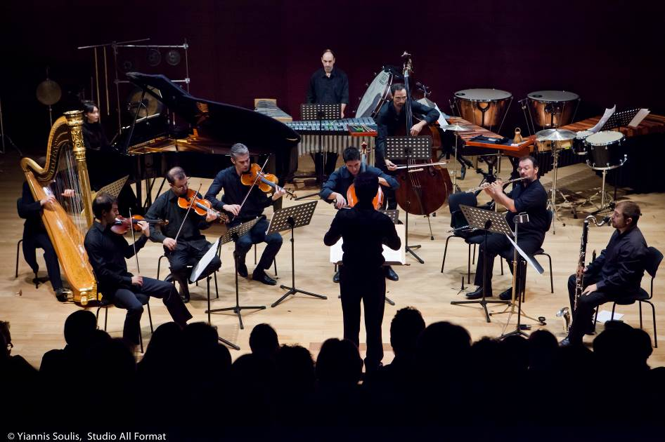
For the past 6 years, the Ergon Ensemble – an ensemble specialized in contemporary music – has regularly appeared in the most important concert venues and festivals in Athens, such as the Megaron, the Hellenic Festival and the Onassis Cultural Centre, enjoying great critical and audience acclaim. One of the leading contemporary music ensembles in Greece, Ergon’s mission is to promote, through its virtuosic performances and ambitious programming, contemporary masterpieces, particularly the most recent works of Greek and foreign composers.

As an Athens-based ensemble with the advantage of direct access to the contemporary compositions by Greek composers, the Ensemble’s ultimate aim is the endorsement of Greek musical creation on the international music scene.

Founded in 2008, Ergon is based on a core formation of soloists and is joined by talented artists specialized in new music, shaping therefore a flexible musical ensemble of immense versatility. Its members comprise some of the most talented young musicians of our time, all participants of the International Ensemble Modern Academy. The musicians of Ergon come from a wide variety of academic and professional backgrounds, but share a mutual love for the performance of contemporary music and a great commitment to performing excellence.

Apart from their regular concerts, their key activities include CD recordings, educational activities and inter-disciplinary collaborations, which combine various forms of performing arts such as Dance, Music Theatre and Multimedia.

The Ergon Ensemble works in close collaboration with the Ensemble Modern, and it is supported and guided by the knowledge and the valuable experience of the world-leading ensemble of new music. For 2013-2014, the Ergon Ensemble has the friendly support of the Ernst von Siemens Music Foundation. Artistic coordination: Alexandros Mouzas

LECTURE
“Film music: from the silent era to the coming of sound”
ALEXANDROS MOUZAS

Sunday 5 October 2014
The Shoe Factory, Nicosia / 7:30pm
Entrance: Free

Alexandros Mouzas, Artistic Director of the Ergon Ensemble will track the history of film music – from its early beginnings to recent days, the methods and practices of producing film music, as well as the secrets in shaping a language that directly communicates with the viewer. The lecture, which will also feature rare cinematic and photographic footage, will be given in Greek and will last approximately two hours.

Alexandros Mouzas
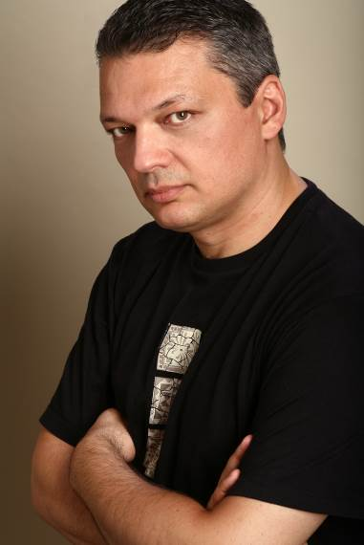
Alexandros Mouzas studied composition with Theodore Antoniou, advanced theory with Haris Xanthoudakis and electronic music with Dimitris Kamarotos. He has composed for various ensembles and has received many commissions from organisations and orchestras, including: The education program S-[cool]-life (2014), film scores for Len Lye’s Tusalava (2012) and Alan Schneider’s Film (2012), Asma Asmaton (2008), Struwwelpeter (2004), Trisha Never Left Home (1999) by the Athens Megaron; Cam-Media (2009) by the Athens Camerata (the Friends of Music Orchestra); film score for Luis Buñuel’s Un chien Andalou (2013) by the Ergon Ensemble; Stones of Destiny (2010), Giant with the Red Boots (2010), Trisevgeni (2008) by the Orchestra of Colors; Monologue (2001) by Alea III, Boston; Prima Materia (1996) by the Greek National Radio.

Many of his works have also been performed by the Athens State Orchestra, the Orchestra of Patras, the Kyiv Classic Orchestra, amongst others. Alexandros Mouzas has collaborated with the choreographer Konstantinos Michos and the 'Lathos Kinissi' dance group in many productions, among them Trisha Never Left Home, Days of Vironas, Papageno and Calamity till the Dawn, as well as the Airesis Dance Company.

His professional activities include image-related music. He has written original music for short films, television series, documentaries and commercials for the majority of the Greek television channels. In 2003, he was the artistic director of the Greek Section of the European program “New Media Edge Project”, and in 2004, he was commissioned by the Athens 2004 Organizing Committee, to compose original music for the Athens Olympic Games corporate videos. His recent professional activities include production management of various important CD releases of Greek orchestral music. He is the manager and founding member of the Ergon Ensemble, he runs his own production company, Anax – Cultural Projects and he teaches music technology and Film music at top schools in Athens.

Alexandros Mouzas has conceived and coordinated the educational programmes Cam-media and S-[cool]-life for high school students, and he has been coordinating the Festival of Sacred Music of Patmos, since 2009, and productions such as Tribute to Iannis Xenakis (Athens Festival), Peter Maxwell Davies: Icones (Megaron-The Athens Concert Hall) and Silent Films and Music (Michalis Cacoyannis Foundation and Megaron-The Athens Concert Hall). His latest music-theatre piece, City Lives, was presented at the Athens Megaron in May 2014.

Mouzas is a member of the Greek Composers’ Union, and had been the Treasurer of its Board of Directors during the period 1998-2012. His CD Music for an imaginary film, with orchestral works performed by the Sofia Philharmonic Orchestra, was released by NAXOS.

screening
Ost-original Soundtrack: "A documentary film about music in the motion pictures"

Sunday 5 October 2014
The Shoe Factory, Nicosia / 9:30pm
Entrance: Free

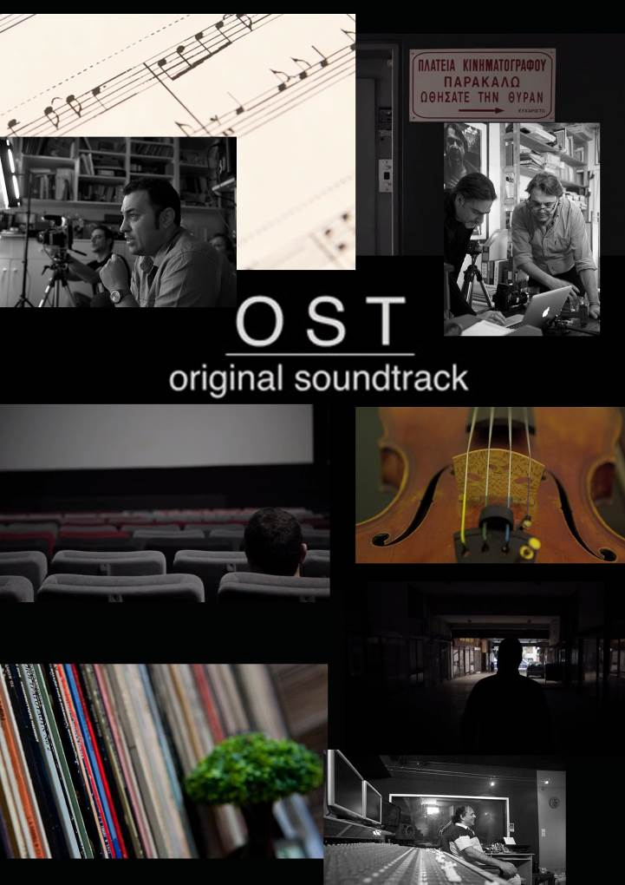
OST-ORIGINAL SOUNDTRACK: "A DOCUMENTARY FILM ABOUT MUSIC IN THE MOTION PICTURES"

Director: Fanis Logothetis
Story Research: Spiros Andreadis
Duration: 60’
Languages: Greek, English, French with Greek Subtitles
Trailer: https://www.youtube.com/watch?v=j5e6RQFhvDY

Ost-Original Soundtrack is a documentary about music in motion pictures. It is an independent production by Fanis Logothetis and Spiros Andreadis, a collective effort to pay tribute to those who inspired us to the creation of what we call today, original soundtrack. The mission of the documentary is to acquaint the audience with a form of art that is fundamental in the film industry, yet it is invisible and relatively unknown to the general public.

Ost-Original Soundtrack tracks the path which the pioneers of creativity and inspiration engrave through the magical world of music and the movies. Their personal experiences, knowledge and opinions guide us step by step to the cinematic process.

The documentary features interviews with a number of renowned film composers from Greece and abroad, such as Nicola Piovani (especially known for his Oscar winning score to Benini’s film La Vita è Bella) and Trevor Jones (famous for his original film scores to films such as The Last of the Mohicans, Mississippi Burning, Runaway Train, Notting Hill, In the Name of the Father), as well as artists from other faculties who give us their very own perspective on the issue of film music.

Ost-Original Soundtrack is certainly an exciting journey that transfers the viewer to the amazing world of cinematic music.

CONCERT
“FROM CONTEMPORARY CLASSICS TO NEW MUSIC”
VIOLIN AND PIANO RECITAL WITH HUGO TICCIATI / VIOLIN & HAYK MELIKYAN / PIANO

Monday 6 October 2014
The Shoe Factory, Nicosia / 8:30pm
Entrance: €10

Recognized internationally as one of the most versatile and imaginative performers of the 20th century and Contemporary Music and among today's most engaging virtuoso pianists pianist Hayk Melikyan returns to Cyprus to join forces with the fascinating violinist Hugo Ticciati, who has been described by the great Arvo Pärt as “an artist who has a rare ability to convey a profound understanding of the music and shed light on its spiritual intent”. The recital will include a number of contemporary classics by composers such as Messiaen, Lutoslawski, Pärt, Takemitsu, interspersed with works by the younger generation of internationally renowned composers such as Evis Sammoutis, Vito Zuraj, Esaias Järnegard and Albert Schnelzer.

The story of the genesis of Olivier Messiaen’s Quartet for the End of Time (1941) is widely known, oft repeated, but what is often ignored in the telling is the remarkable nature of what was produced, given what one would have expected in the circumstances. Born in the midst of war, death, frost and famine, the Quartet, though explicitly apocalyptic, is not a fiery Requiem, striving to translate divine wrath, but rather an intensely devotional, transcendent composition, that reaches a realm in which such worldly troubles matter little, or not at all. Played in the chilly night for the prisoners and the German guards, Messiaen’s meditative chamber suite was received with rapt silence: “Never have I been heard with as much attention and understanding,” he later recalled. So impressed was his guard patron that Messiaen was smuggled back to Paris to continue his work. It is little surprise, for the Quartet is one of the most remarkable compositions of the 20th century. A deeply committed Catholic, Messiaen composed not a lament of war or death, or a bitter strike at oppression, but instead a paean to the world beyond (and above) of transcendence, redemption, and even, of joy. Takemitsu’s Rain Tree Sketches II (1992) was composed as a memorial piece for Messiaen, who was a strong influence on the composer. He had composed several pieces based on Kenzaburo Oe's short stories about the rain tree, whose many small curved leaves trap the rainfall then release the water to the ground over time long after the rain has ceased. "An ingenious tree, isn't it?" asks the story. The work is French in sound, somewhere between Messiaen and Debussy in harmonic language. The short piece is one of the most joyful and accessible pieces Takemitsu wrote. It was also his last piano piece.

Witold Lutoslawski’s fame rose to international stardom after the Second World War and the premiere of his First Symphony in 1948. He composed his Partita for Violin and Piano in the autumn of 1984 for Pinchas Zuckerman and Marc Neikrug at the request of The Saint Paul Chamber Orchestra. Consisting of five movements, three of which give the impression that they rhythmically belong to the tradition of the Baroque keyboard music, the Partita is nevertheless quite ground-breaking in terms of its harmonic and melodic material. Regarding his choice of title Lutoslawski has explained: "The word 'partita,' as used by Bach to denominate some of his suite-like works, appears here to point out a few allusions to Baroque music, e.g. at the beginning of the first movement, the main theme of the Largo, and the gigue-like Finale.

Arvo Pärt (b. 1935) is an Estonian composer, often identified with the school of minimalism, though he rejects this label (and, even more vehemently, the label of "holy minimalism", which he describes as meaningless). He composed Fratres, originally for string quintet and wind quintet, in 1977 for Hortus Musicus, an early-music ensemble in Tallinn. The title refers to the fraternal spirit of the Hortus Musicus. In the decades since then he has written versions of this popular piece for many different combinations: wind octet and percussion, strings and percussion, and string quartet— and versions in which violin, cello, or guitar take a solo role.

Programme:

Olivier Messiaen (1908-1992): Louange à l’immortalité de Jésus from the Quartet for the End of Time (1941)
Esaias Järnegard (b. 1983): Stretto (2010)
Albert Schnelzer (b. 1972): Solitude (1999)
Witold Lutoslawski (1913-1994): Partita (1984)

Interval

Arvo Pärt (b. 1935) : Fratres (1977)
Vito Zuraj (b.1979) : Tango (2000)
Toru Takemitsu (1930-1996): Rain Tree Sketches II (1992)
Evis Sammoutis (b. 1979): Prelude (2002)
Albert Schnelzer (b. 1972): Apollonian Dances (2003)

HUGO TICCIATI / VIOLIN
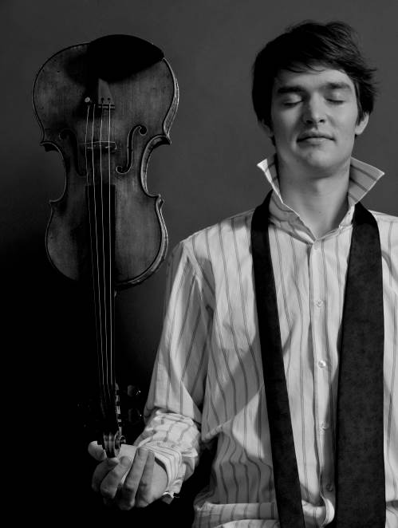
“Hugo has a rare ability to convey a profound understanding of the music and shed light on its spiritual intent”
—Arvo Pärt

Hugo Ticciati is an exceptional violinist with a uniquely intellectual approach to his work, incorporating aspects of literature, philosophy, spirituality and meditation. Since his debut at the age of twelve, Hugo has performed concertos with orchestras in Britain, Sweden, Romania, Japan, Korea, North America and Estonia, and collected numerous international prizes. His carefully balanced programme is certain to soothe the mind and refresh the senses!

Ticciati embraces the world of contemporary music, collaborating with composers such as Sven-David Sandström, Albert Schnelzer, and Anders Hillborg, among others. In the coming seasons he will be performing world premières of concertos dedicated to him in Europe, Asia, and North and South America. He also loves devising concerts and events that combine music with the other arts, notably dance and literature. He is currently working with the English composer Bill Connor on An Improvised Violin Concerto. Last season’s highlights included concertos by Bach, Mozart, Prokofiev, Schnittke, Hartmann, Shchedrin, Piazzolla, Auerbach, Glass, Lutoslawski, Takemitsu and world premieres of concertos by Tobias Broström, Sergey N. Evtushenko and Albert Schnelzer in venues including Carnegie Hall, Mariinsky Theatre Concert Hall, Chicago Symphony Hall and Cadogan Hall (London). Next season features tours in China and the USA with his own string orchestra, a series of concerts at the Muziekgebouw aan ‘t IJ, Amsterdam and a weekend of concerts at the Wigmore Hall.

Hugo Ticciati has a passion for chamber music and gives regular recitals in prestigious halls across Europe and the Far East, collaborating with artists such as Anne-Sofie von Otter, Steven Isserlis, Angela Hewitt, Evelyn Glennie, Michael Collins, Torleif Thedéen, Leslie Howard, Staffan Scheja, Michael Tsalka and Henrik Måwe. He is also regularly invited to renowned music festivals such as The Baltic Sea Festival (Sweden), Hermitage Music Festival (St Petersburg), St-Denis-Festival (Paris), Cervantino (Mexico), Edinburgh Festival (England), Gotland Chamber Music Festival (Sweden). Hugo is the artistic director of his own festival O/MODƏRNT at Ulrikdal’s Palace Theatre Confidencen, Stockholm, and a string festival in Kazan, Russia.

Hayk MELIKYAN / piano
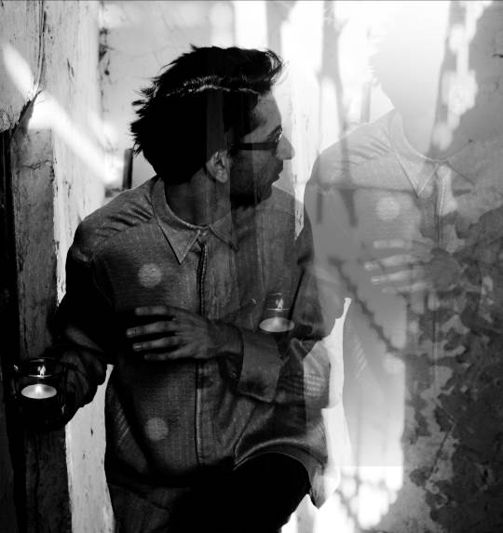
“I am very grateful to Hayk Melikyan that he took the risk of creating that piece…”
György Kurtág

Hayk Melikyan is recognized internationally as one of the most versatile and imaginative performers of the 20th Century and Contemporary Music and among today's most engaging virtuoso pianists. His international concert début took place at the “Concerto di Concerti” International Festival of the 20th Century Music in Rome in 2000. He leads an active concert life, playing throughout Europe, Asia and the Americas.

After having won the Second Prize in the International Piano Competition of the 20th Century and Contemporary Music “Premio Valentino Bucchi” in Rome in 2000 he included contemporary music as the leading part of his concert programmes. In 2012, Hayk Melikyan was awarded a Gold Medal by the Moscow Composers Union for his contribution and promotion of the World Contemporary Music, while in 2013, he was awarded the Title of an Honorary Artist of the Republic of Armenia. He is the first performer of numerous works by many composers of our time and dozens of pieces were especially composed for him.

In 2009, Melikyan initiated the Concert Series of “1900+”, which promotes the piano music of composers born after 1900. Several solo albums by Hayk Melikyan have been released since 2007 and in 2014 his solo album was released by Naxos. Hayk Melikyan is regularly conducting master-classes on Contemporary music all over the world and he is regularly invited to perform in music festivals such as Festival de Valmagne and Festival de Musique en Côte de Nacre (France), Festival O/MODƏRNT (Sweden), the Geneva Piano Festival , the Warsaw Royal Arcades of Art Festival, and the Nuovi Spazi Musicali Festival (Italy). As a composer, Melikyan has produced a number of piano solo, chamber, instrumental, vocal and symphonic works. His piano transcriptions, concert paraphrases and arrangements are among the favourite ones in the repertoires of many pianists worldwide. Hayk Melikyan has earned a reputation as one of the most creative improvisators by world audience, which adds an unusual value to his recitals.

SCREENING
“War & Peace: The Film” & “Re-Veil-Le”

TALK
“LIVING ONE'S PRACTICE : PERFORMING ONE’S WORK”
JOANNA JONES / VISUAL ARTIST

Tuesday 7 October 2014
The Shoe Factory, Nicosia / 7:30pm
Entrance: Free

Screening: WAR & PEACE: THE FILM
Director: Dominic de Vere
Duration: 30’

Dover Arts Development (DAD) commissioned Dominic de Vere to make a “project film” from the many strands of their 18 month War & Peace programme, asking him to make a piece of work that was both documentation and a work in its own right. The resulting 30-minute film is an intelligent response to the brief as well as a fascinating new piece of work by the artist/film-maker on the theme: “The Earth, like the body of an animal, is wasted at the same time as it is repaired. It has a state of growth and augmentation; it has another state, which is that of diminution and decay. This world is thus destroyed in one part, but is renewed in another. From the top of the mountain to the shore of the sea, which are the two extremities of our land, every thing is in a state of change; the rock and solid strath dissolving, breaking and decomposing, for the purpose of becoming soil. The soil travelling along the surface of the earth, in its way to the shore; and the shore wearing and wasting by the agitation of the sea, an agitation which is essential to the purposes of a living world. “ James Hutton

Screening: RE-VEIL-LE
Director: Dominic de Vere
Painter: Joanna Jones
Music: Mihailo Trandafilovski's “Diptych” Violin Concerto No 2
Duration: 19’

In RE-VEIL-LE, the journey of Joanna Jones’ new painting is veiled and revealed in a 19 minute film in symbiosis with Mihailo Trandafilovski's “Diptych” Violin Concerto No. 2. “I decided to make a painting for Dover that would, at the same time, be a metaphor for history and change. Out of a series of photographs – documenting a painting evolving over 42 painting sessions – I made a film", said Joanna Jones. The paintings’ development compositionally parallels the composition of Mihailo Trandafilovski's “Diptych” Violin Concerto, both art forms working synergically with each other. There is no finished painting as the final painted canvas was cut into 324 pieces, a piece of which was given to each audience member with the programme at the work’s premiere at the War & Peace Grand Finale Concert on October 11th 2013 at Dover Town Hall. It was performed by Longbow under the direction of Peter Sheppard Skaerved.

Talk by Joanna Jones: LIVING ONE'S PRACTICE: PERFORMING ONE’S WORK

For an artist, to live one’s practice, to live in a way that perfectly brings together art and life, is to pursue an Utopian project and at the same time constantly question whether and how this can be achieved. This talk aims to show how such a project might be envisaged through the experience of grass-roots cultural activism combined with a more strategic approach to influencing cultural policy and embedding the arts in a town with little experience and considerable scepticism of contemporary art practice, particularly publicly-funded arts projects. The Talk will last approximately 40 minutes and will be given in English.

Joanna Jones lives and works in Dover. After studying painting at The Byam Shaw School and the Royal Academy Schools she spent over twenty years in Germany developing her practice and exhibiting internationally. She returned to the UK in 1997 and, in 2001, was the recipient of an Arts Council Year of the Artist award for a light projection on the cliffs at Samphire Hoe in Kent. Over several decades, Jones’ work has evolved as part of an intense emotional and intellectual process of self discovery and unveiling. Her work encompasses performance and painting. In 2006, she extended her practice in the public realm founding and developing (DAD) Dover Arts Development with artist Clare Smith.

SCREENING
Steve Reich: City Life "A documentary"

Tuesday 7 October 2014
The Shoe Factory, Nicosia / 9:30pm
Entrance: Free

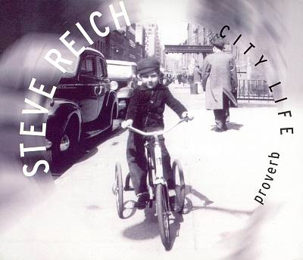
STEVE REICH: CITY LIFE "A DOCUMENTARY"

Director: Manfred Waffender
Duration: 61’
Language: English

Born in 1936, Steve Reich is one of the most significant American composers of the 20th century. Manfred Waffender's major documentary traces the background to the creation of his piece City Life. Reich masterfully captures sounds from New York City street life with the aid of two sampling keyboards and microphone, forging the noise of the city street into a work for string quartet, wind, percussion and two pianos. The film culminates in a performance of the piece from the Frankfurt Opera House, with the Ensemble Modern conducted by Sian Edwards.

Reich said about City Life, “The idea that any sound may be used as part of a piece of music has been in the air during much of the 20th Century. From the use of taxi horns in Gershwin’s An American in Paris through Varese’s sirens, Antheil’s airplane propeller, Cage’s radio, and rock and roll’s use of all of the above and more starting at least in the 1970s, and more recently in rap music, the desire to include everyday sounds in music has been growing. The sampling keyboard now makes this a practical reality. In City Life not only samples of speech but also car horns, door slam, air brakes, subway chimes, pile driver, car alarms, heartbeats, boat horns, buoys, fire and police sirens are part of the fabric of the piece.”

CONCERT
“an open-air concert of live electronics, improvisation & free jazz”
SOUNDSCAPES

Wednesday 8 October 2014
The Shoe Factory (Roof Garden), Nicosia / 8:30pm
Entrance: €10

The 6th International Pharos Contemporary Music Festival concludes with an open-air concert of live electronics, improvisation and free jazz by Soundscapes – a fascinating duo programme with Johannes Schwarz (bassoon) and Sascha Armbruster (saxophone), who will be joined by sound-engineer Sebastian Schottke. The concert will take place at the exquisite roof-garden of The Shoe Factory, on Wednesday 8 October 2014, 8:30pm, which will be transformed for the first time as an exclusive open-air concert platform. This way, the audience will be able to enjoy an extraordinary, unconventional, musical experience and an amazing symbiosis between the natural world of sound and electronics in a leisurely setting with a glass of wine. The concert is co-organised with the Goethe-Institut Zypern.

SOUNDSCAPES
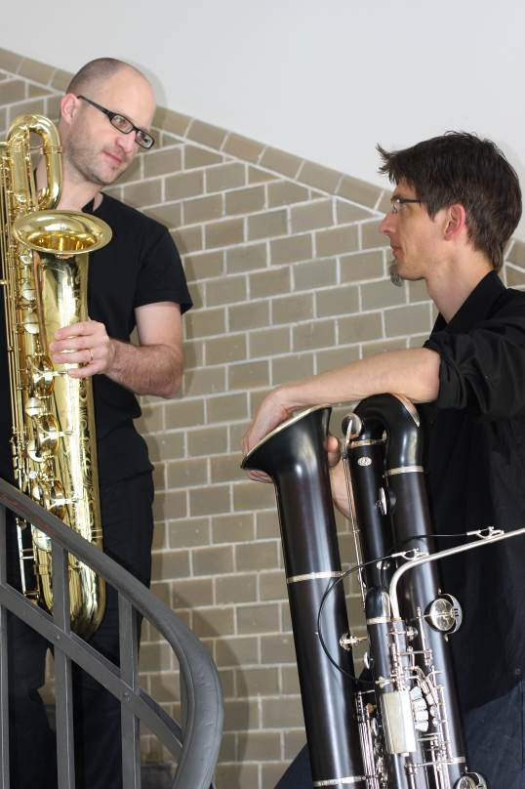
Soundspaces is a fascinating project for bassoon, saxophone and electronics formed by Johannes Schwarz (bassoon) and Sascha Armbruster (saxophone). The genesis of Soundspaces has its roots on the common background of the two musicians: Both Johannes and Sacha have performed and interpreted pieces in their solo programmes, which have been highly influenced by the use of synthesized music, therefore they decided to join forces and integrate electronic music as the central theme of their programme. The high standard and freshness of Soundspaces is enhanced by the inclusion of live-electronic and live-sampling straight into the live improvisations. The electronic sound-system of Soundspaces was exclusively developed at the ZKM in Karlsruhe and the ICST (Institute for Computer Music and Sound Technology﻿ Zürich).

Johannes Schwarz (bassoon) has been a member of the Ensemble Modern since 2003, and the artistic leader of the Ensemble Modern Academy, coordinating all educational projects of Ensemble Modern, since 2013. Apart from regularly performing in renowned radio and symphony orchestras, he performed for several years in baroque ensembles on original instruments, and has appeared with radio big bands as well as various improvisation ensembles. His CD productions feature works for solo bassoon premiered by him as well as classical and baroque music, but also a number of arrangements.

After winning the “Premier prix à l' Unanimité” at the Conservatoire de Paris, where he studied with Claude Delangle, Sascha Armbruster (saxophone) decided to specialize in contemporary music. His concert-activities as a soloist and with chamber groups have brought him to famous festivals in Japan, the US and all over Europe, and he has appeared with leading contemporary ensembles such as the Ensemble Modern, Ensemble Recherche and Klangforum Wien. He is the founder and member of the ARTE Quartett, and since 2011, he has been tutor at the Conservatory of Lucerne.

Sebastian Schottke studied sound engineering and music production at the University of Music and Performing Arts in Vienna, and won a scholarship to the International Ensemble Modern Academy in Frankfurt / Main. His intensive activities (in concert and studio) in the field of contemporary music led him to collaborations as a sound director with numerous composers, ensembles and dance companies at festivals such as the Avignon Festival, the Edinburgh Festival, the Ruhrtriennale, the Munich Biennale, the Beethovenfest Bonn, Ultima Oslo Contemporary Music Festival, Wien Modern and the Modern Academy Concert Series in Hong Kong. Since 2008, Sebastian Schottke works as a sound engineer for the ZKM (Zentrum für Kunst und Medientechnologie) in Karlsruhe.

